# Title: On “About a company” page. Clicking on “ПРО КОМПАНІЮ” and on “ЗВОРОТНІЙ ЗВ’ЯЗОК” phrases doesn't lead to any pages.

**Priority:** Low

**Severity:** S4 Minor

**Environment:** Browser Mozilla Firefox 118.0.1 (64-bit)

**Steps to reproduce**

1. Go to the Main page <https://multiplex.ua/>

2. Click on “burger-menu” at the left upper-corner of the page.

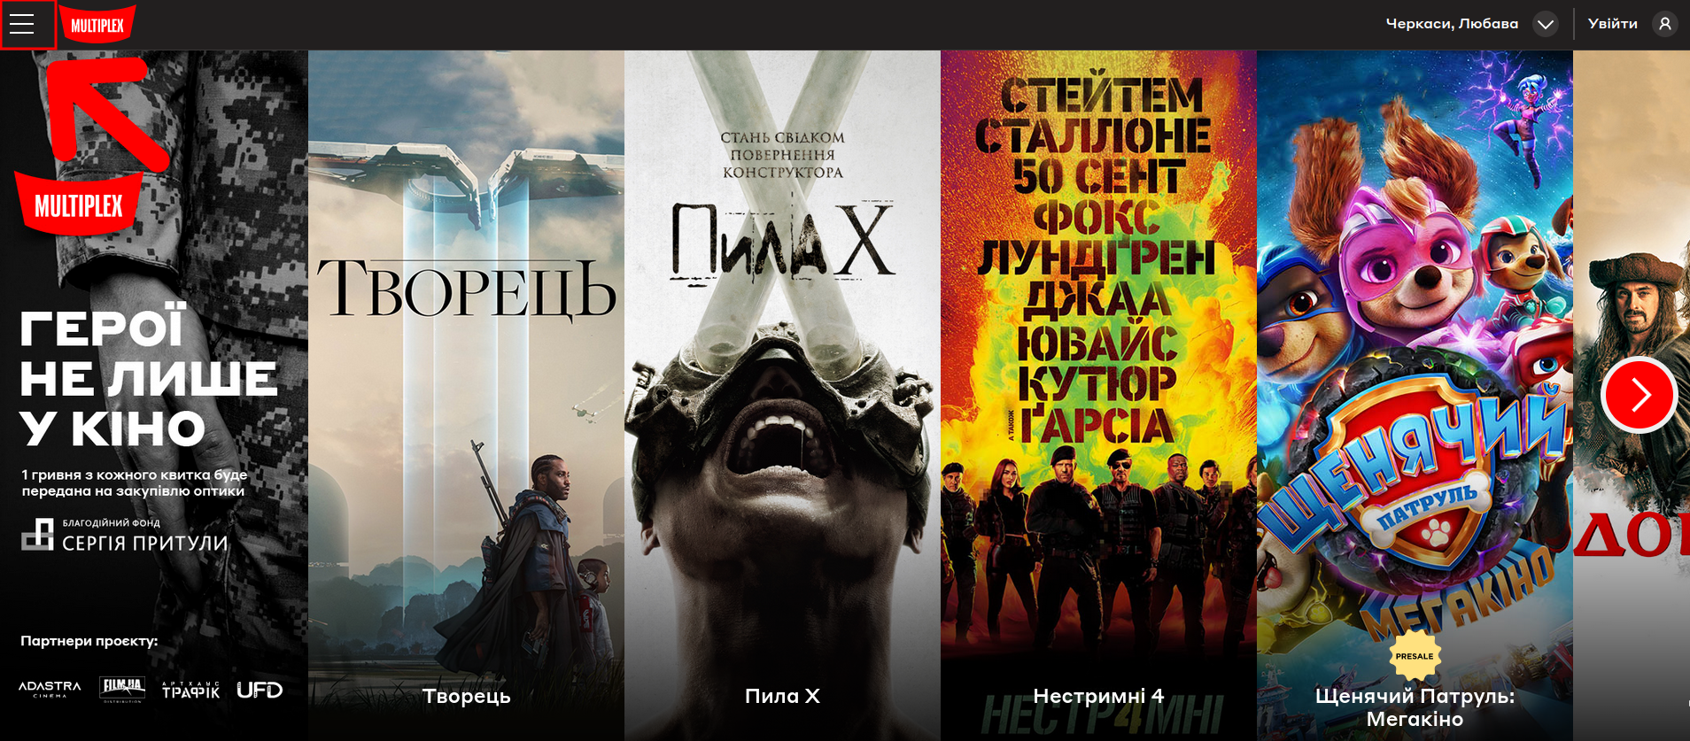

3. On the left-slide menu, click on “Про компанію”

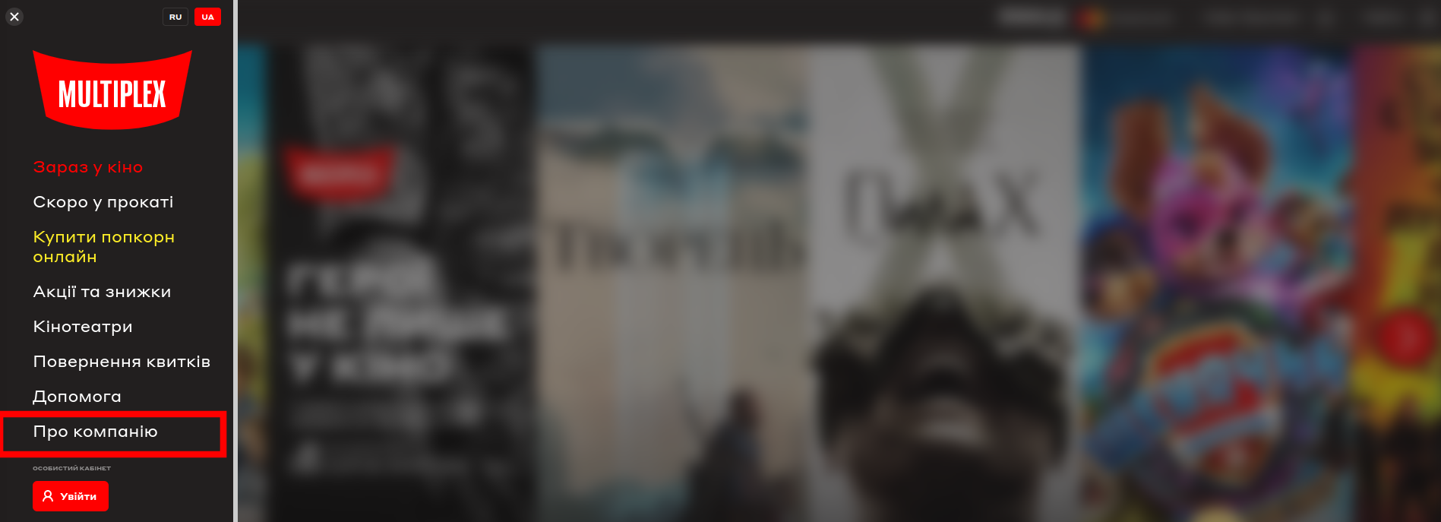

4. On the opened page, click on “ПРО КОМПАНІЮ” or on “ЗВОРОТНІЙ ЗВ’ЯЗОК” phrases

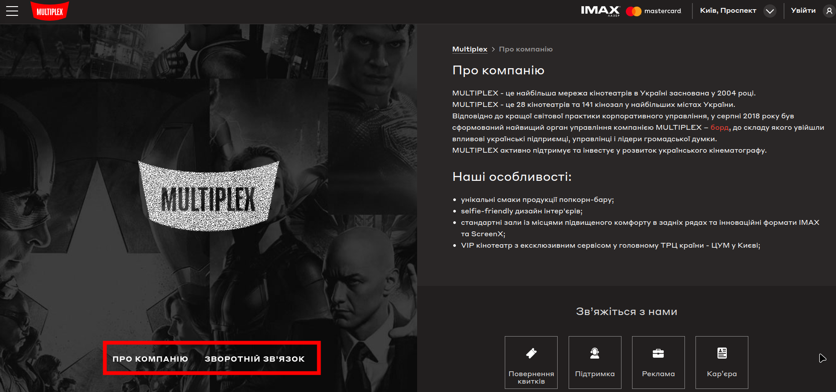

**Actual result**

Nothing happened. Although these phrases are clickable, clicking on it, doesn’t lead a user to any directions.

**Expected result**

A user must be redirected to a dedicated appropriate pages (or anchors). Or these phrases must be deleted (at least in the Desktop version of the website)

*Screenshot from* ***Jira****:*

